**Exercise 1: Control Structures**

**Scenario 1:**

set serveroutput on;

declare

cursor cur_senior_loans is

select l.loan_id,

l.interest_rate

from customers c

join loans l on l.customer_id = c.customer_id

where c.age > 60;

begin

-- automatic loop through the result set

for rec in cur_senior_loans loop

update loans

set interest_rate = round(rec.interest_rate * 0.99, 2) -- 1 % off

where loan_id = rec.loan_id;

dbms_output.put_line(

'loan ' || rec.loan_id || ' discounted to ' ||

round(rec.interest_rate * 0.99, 2)

);

end loop;

commit;

exception

when others then

rollback;

raise;

end;

/

**OUTPUT:**

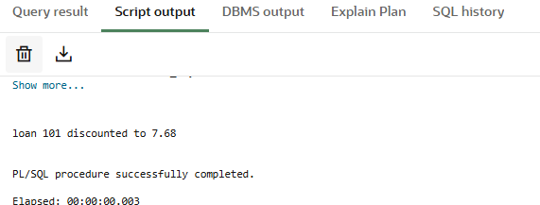

**Scenario 2:**

set serveroutput on;

create table customer_accounts(

  customer_id number primary key,

  balance     number,

  isvip       varchar2(5)

);

insert into customer_accounts values (1, 15000, 'false');

insert into customer_accounts values (2, 8000 , 'false');

commit;

begin

  for rec in (

      select customer_id, balance

      from   customer_accounts

      where  balance > 10000

  ) loop

      update customer_accounts

      set    isvip = 'true'

      where  customer_id = rec.customer_id;

      dbms_output.put_line(

         'customer '||rec.customer_id||' promoted to vip'

      );

  end loop;

  commit;

end;

/

select * from customer_accounts;

**OUTPUT:**

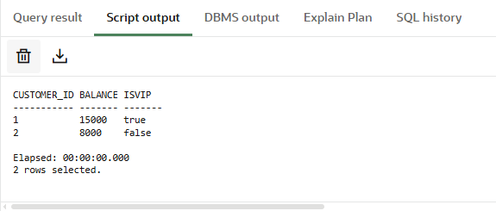

**Scenario:3**

set serveroutput on;

begin

    for rec in (

        select customer_name,

               due_date

        from   loan_due

        where  due_date between trunc(sysdate)

                         and     trunc(sysdate)

    ) loop

        dbms_output.put_line(

            'reminder: ' || rec.customer_name ||

            ', your loan is due on ' ||

            to_char(rec.due_date, 'dd-mon-yyyy')

        );

    end loop;

end;

/

**OUTPUT:**

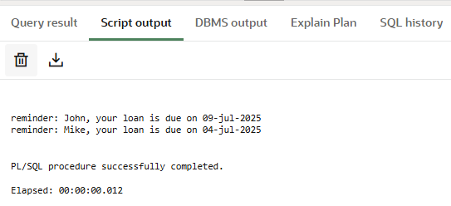

**Exercise 3: Stored Procedures**

**Scenario 1:**

set serveroutput on;

create table savings_accounts (

    account_id    number primary key,

    balance       number(10,2),

    account_type  varchar2(20)

);

insert into savings_accounts values (1, 10000, 'SAVINGS');

insert into savings_accounts values (2, 5000,  'SAVINGS');

insert into savings_accounts values (3, 7000,  'CURRENT'); -- not savings

commit;

create or replace procedure ProcessMonthlyInterest is

    c_rate constant number := 1.01;

begin

    update savings_accounts

    set    balance = round(balance * c_rate, 2)

    where  upper(account_type) = 'SAVINGS';

    dbms_output.put_line(sql%rowcount || ' savings accounts updated.');

    commit;

exception

    when others then

        rollback;

        raise;

end;

/

exec ProcessMonthlyInterest;

select * from savings_accounts;

**OUTPUT:**

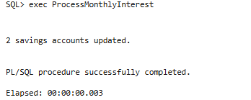

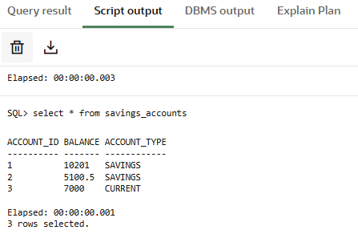

**Scenario :2**

set serveroutput on;

create table employees (

    emp_id       number primary key,

    emp_name     varchar2(50),

    department   varchar2(50),

    salary       number(10,2)

);

insert into employees values (1, 'Alice', 'IT',     50000);

insert into employees values (2, 'Bob',   'HR',     45000);

insert into employees values (3, 'Carol', 'IT',     60000);

insert into employees values (4, 'David', 'SALES',  40000);

commit;

create or replace procedure UpdateEmployeeBonus(

    p_dept    in varchar2,

    p_bonus   in number

) is

    v_factor number := 1 + (p_bonus / 100);

begin

    update employees

    set    salary = round(salary * v_factor, 2)

    where  upper(department) = upper(p_dept);

    dbms_output.put_line(sql%rowcount || ' employee(s) in ' || upper(p_dept) || ' received a ' || p_bonus || '% bonus.');

    commit;

exception

    when others then

        rollback;

        raise;

end;

/

exec UpdateEmployeeBonus('IT', 10);

select * from employees;

**OUTPUT:**

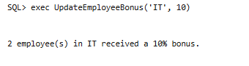

**Scenario:3**

set serveroutput on;

create table bank_accounts (

    account_id   number primary key,

    customer_id  number,

    balance      number(10,2)

);

insert into bank_accounts values (101, 1, 10000.00); -- sender

insert into bank_accounts values (102, 1, 5000.00);  -- receiver

insert into bank_accounts values (103, 2, 2000.00);  -- other account

commit;

-- 3. create the stored procedure

create or replace procedure TransferFunds(

    p_from_account_id in number,

    p_to_account_id   in number,

    p_amount          in number

) is

    v_from_balance number;

begin

    select balance into v_from_balance

    from bank_accounts

    where account_id = p_from_account_id

    for update;

    if v_from_balance < p_amount then

        raise_application_error(-20001, 'Insufficient balance in source account.');

    end if;

    update bank_accounts

    set balance = balance - p_amount

    where account_id = p_from_account_id;

    update bank_accounts

    set balance = balance + p_amount

    where account_id = p_to_account_id;

    commit;

    dbms_output.put_line('Transferred ₹' || p_amount ||

                         ' from account ' || p_from_account_id ||

                         ' to account ' || p_to_account_id);

exception

    when others then

        rollback;

        dbms_output.put_line('Transfer failed: ' || sqlerrm);

end;

/

exec TransferFunds(101, 102, 2000);

select * from bank_accounts;

**OUTPUT:**

